**Authorizing ARM Template using Visual Studio 2017**

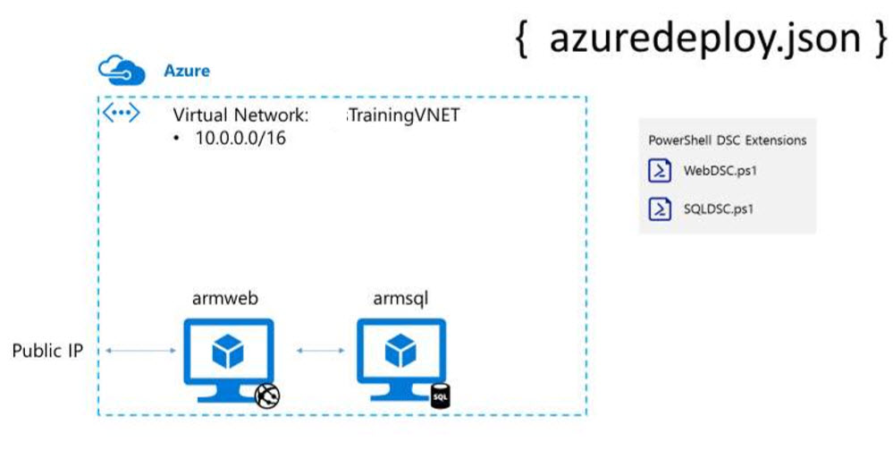

Step 1: Start Visual Studio 2017

File -> New -> Project

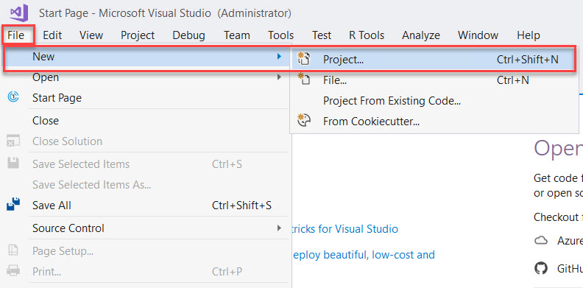

Select Cloud -> Azure Resource Group template

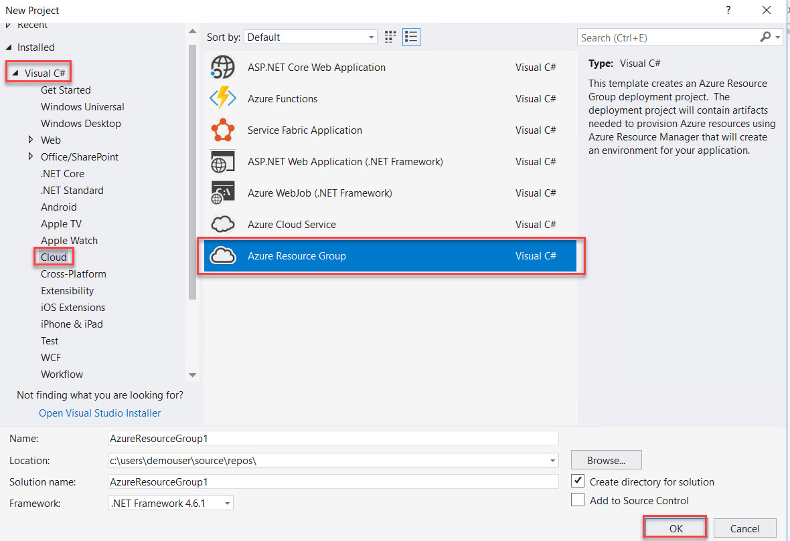

Step 3: Select Blank Template

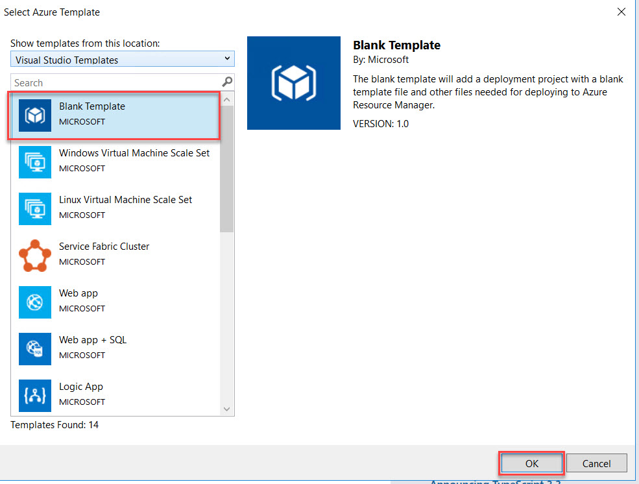

Step 4: Open **azuredeploy.json** file

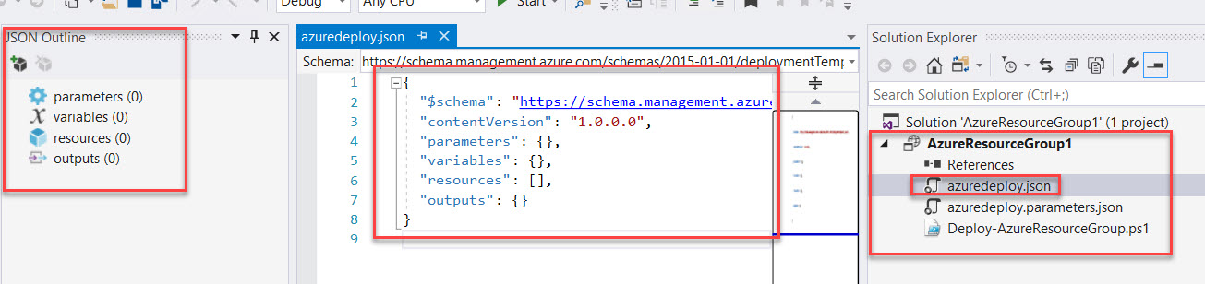

Step 5: Left side JSON Outline window will be there

**Right click on resource -> Add New Resource**

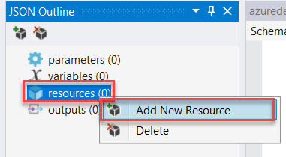

Step 6: Search for Virtual Network

Name: **TrainingVNET**

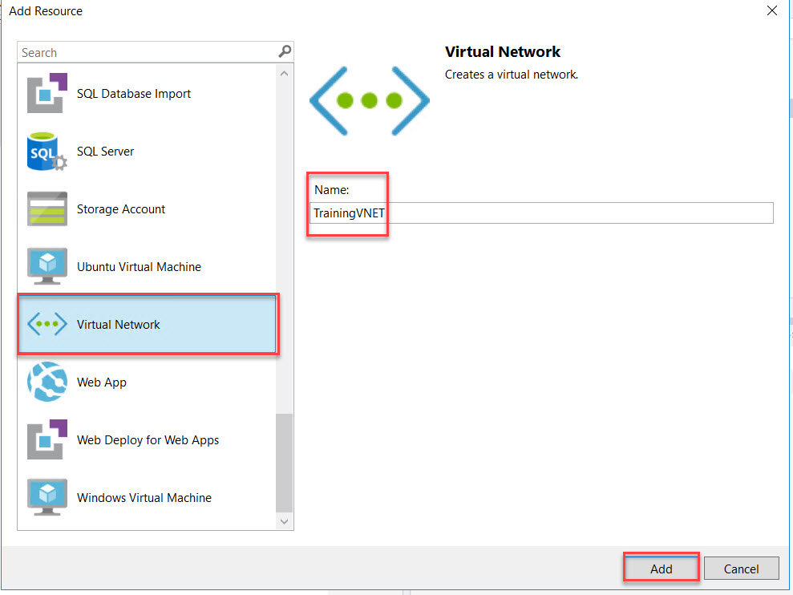

Step 7: Navigate to Virtual Network Variables Ex. VNet1, VNet2

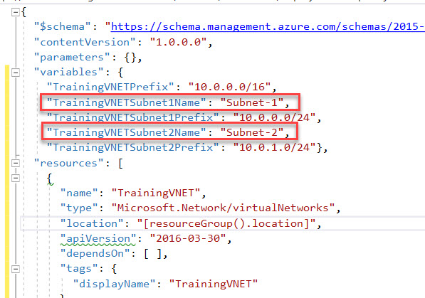

Rename with as below:

"TrainingVNETSubnet1Name": "FrontendNetwork"

"TrainingVNETSubnet2Name": "BackendNetwork"

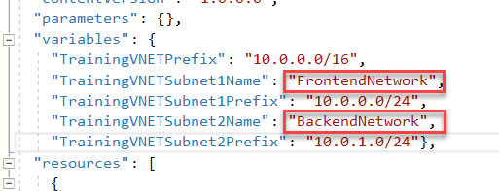

Step 8: Right Click on **Project -> Deploy -> New…**

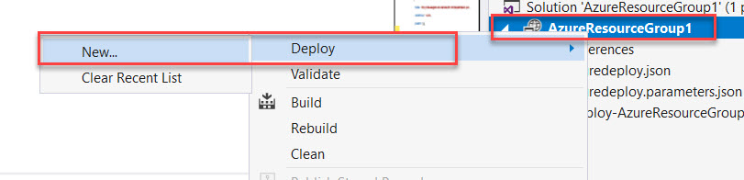

Enter you Microsoft Azure Credentials. Choose Subscription and **Create New Resource Group**

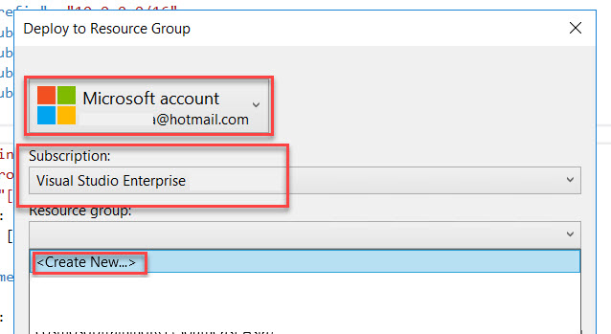

Enter Resource Group Name: **ARMLabRG**

Resource Group Location: Choose any nearest region and Create

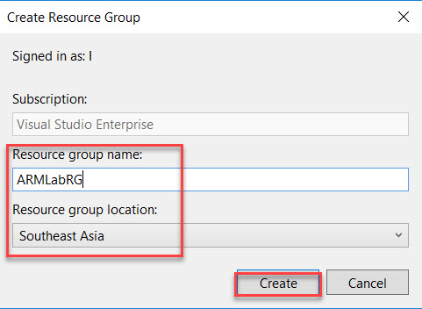

Step 9: Check other options and click on **Deploy** button.

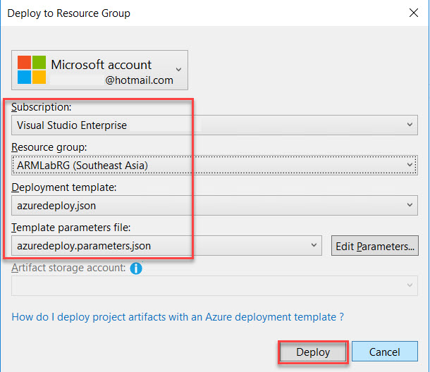

Wait for few minutes to deploy on Cloud

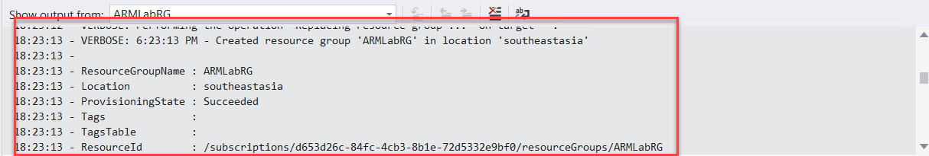

Step 10: Navigate to Azure Portal and check with Resource Group Name.

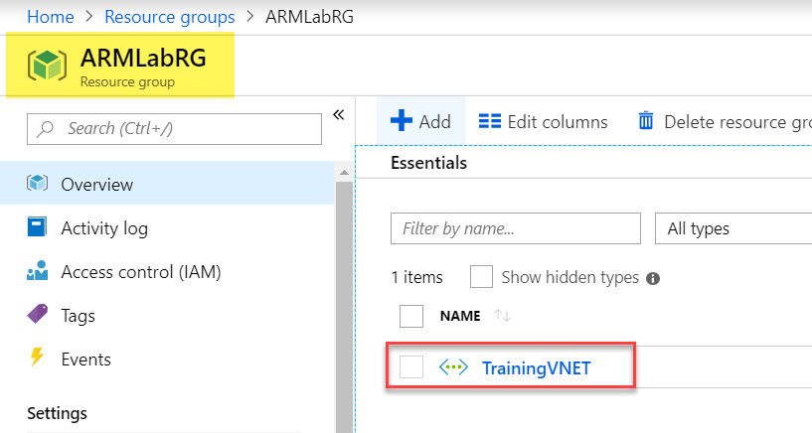

Step 11: Again, Right click on resource -> Add New Resource

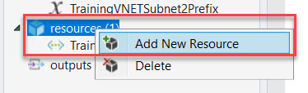

Step 12: Search for Storage

Name: Use any unique short name because at deployment time extra character will be added by Azure. Ex. armlabstrg

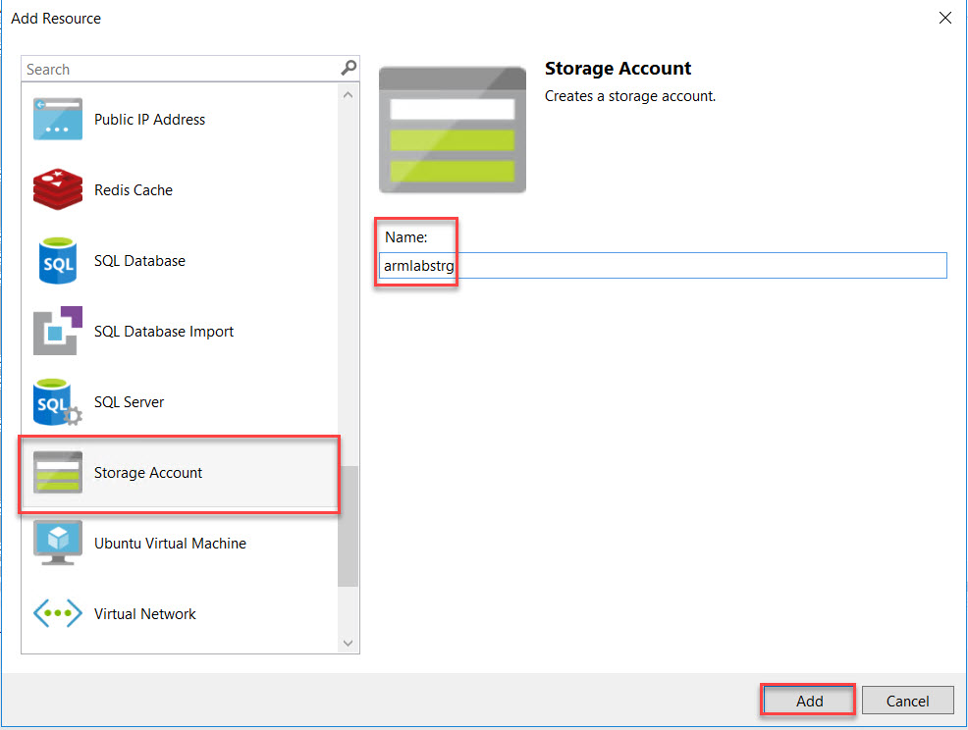

Step 13: Select Storage parameter and Remove **Standard_ZRS** because for Virtual Machine its not supported.

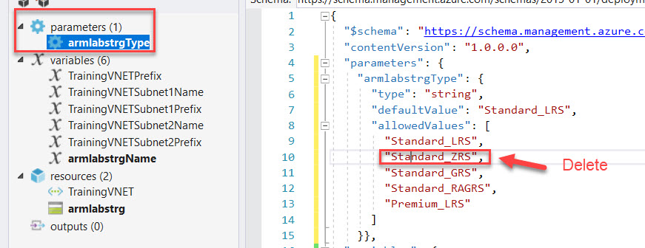

Also we are working with database so we get faster operations

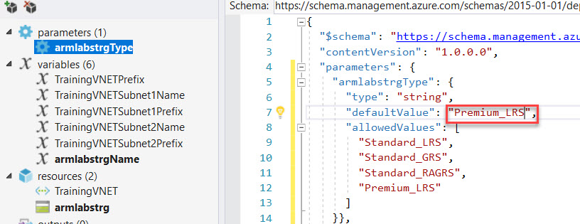

Step 14: Right Click on **resources -> Add New Resource**

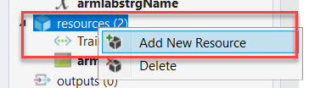

Step 15: Search for Windows Virtual Machine

Enter Name: **WebVM**

Storage Account: Choose from list Ex. armlabstrg

Virtual network/subnet: **[variables(‘TrainingVNETSubnet1Name’)] (TrainingVNET)**

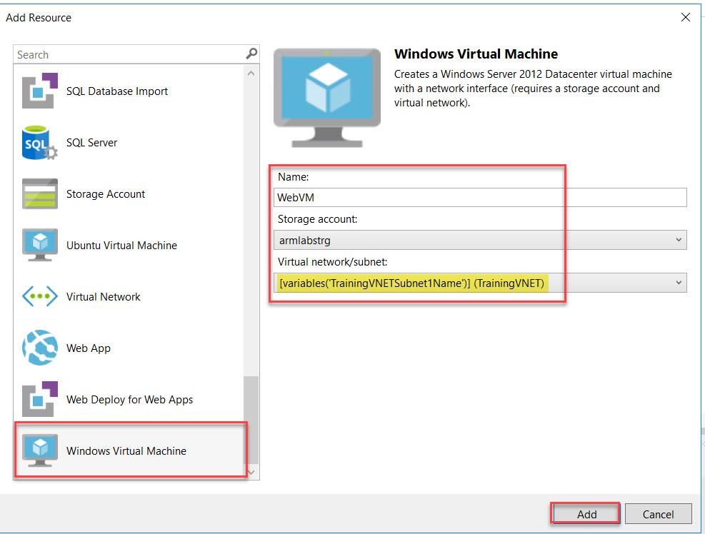

Step 16: Select **WebVMVmSize** variable and change size to **Standard_DS1_v2**

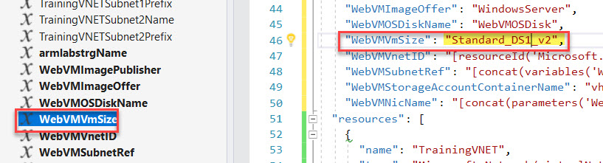

Step 17: Right Click on **resource -> Add New Resource**

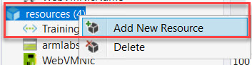

Search for Public IP Address

Name: **WebPublicIP**

Network interface: **WebVMNic**

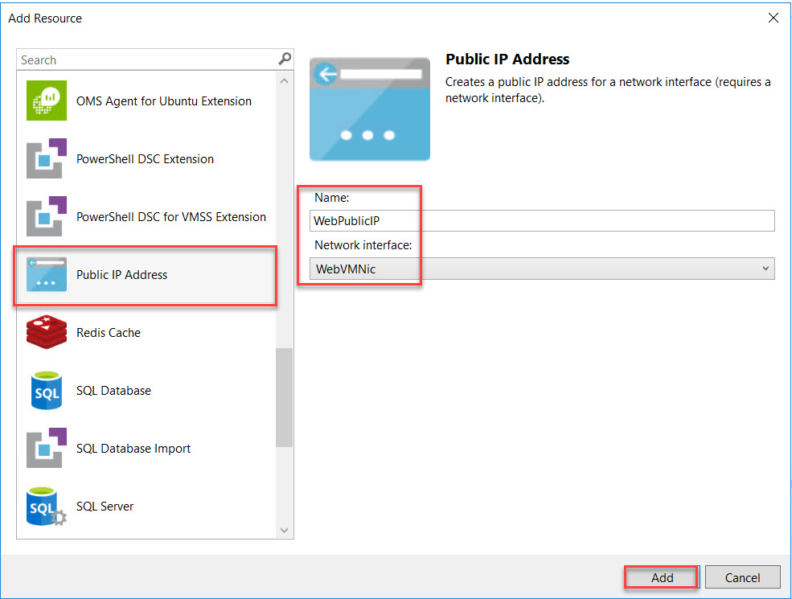

Step 18: Right on **resources -> Add New Resource**

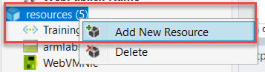

Search for PowerShell DSC Extension

Name: **WebDSC**

Virtual Machine: **WebVM**

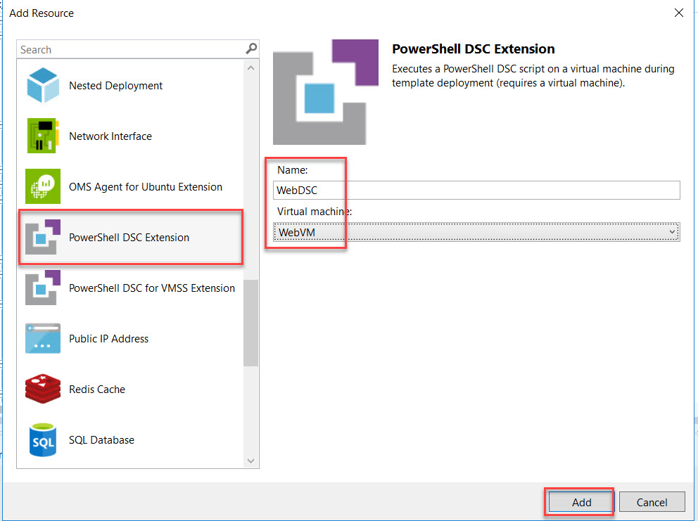

Step 19: Navigate to **Labs Folder** and Open **ARMWEB.ps1.txt** file

Remove default code from **WebDSC.ps1**

Copy complete code from **ARMWEB.ps1.txt** and paste into **WebDSC.ps1**

**Save it.**

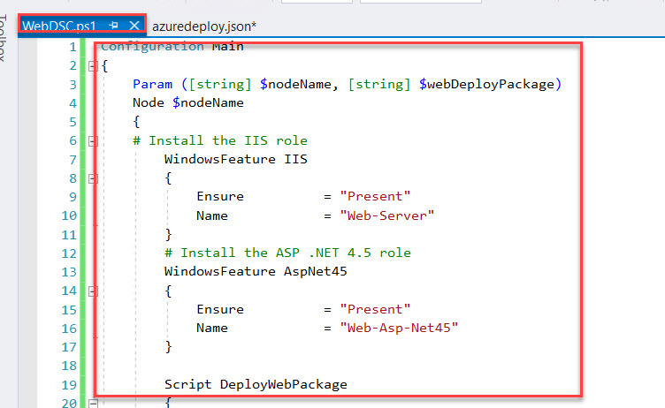

Step 20: Select **artifactsLocationSasToken** parameter

Add **WebPackage**

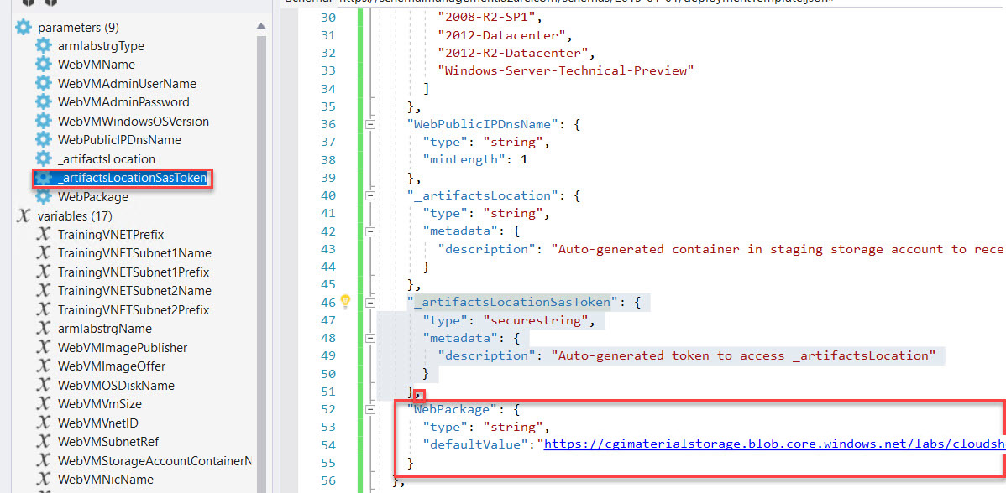

,

"WebPackage": {

"type": "string",

"defaultValue": "https://labfilesstorage.blob.core.windows.net/publicfiles/cloudshop.zip"

}

Step 21: Select **WebDSC** resource and search for **configurationArguments**

First add comma and add below line

"webDeployPackage": "[parameters('WebPackage')]"

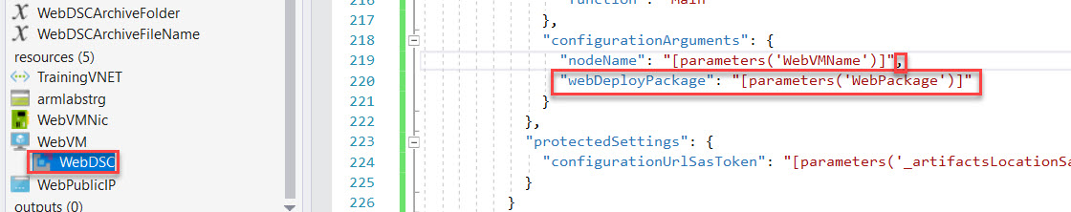

Step 22: Right click on **resources -> Add New Resource**

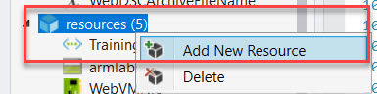

Step 23: Search for Windows Virtual Machine and enter below details

Name: **SQLVM**

Storage Account: armlabstrg

Virtual network/subnet: **[variables(‘TrainingVNETSubnet2Name’)] (TrainingVNET)**

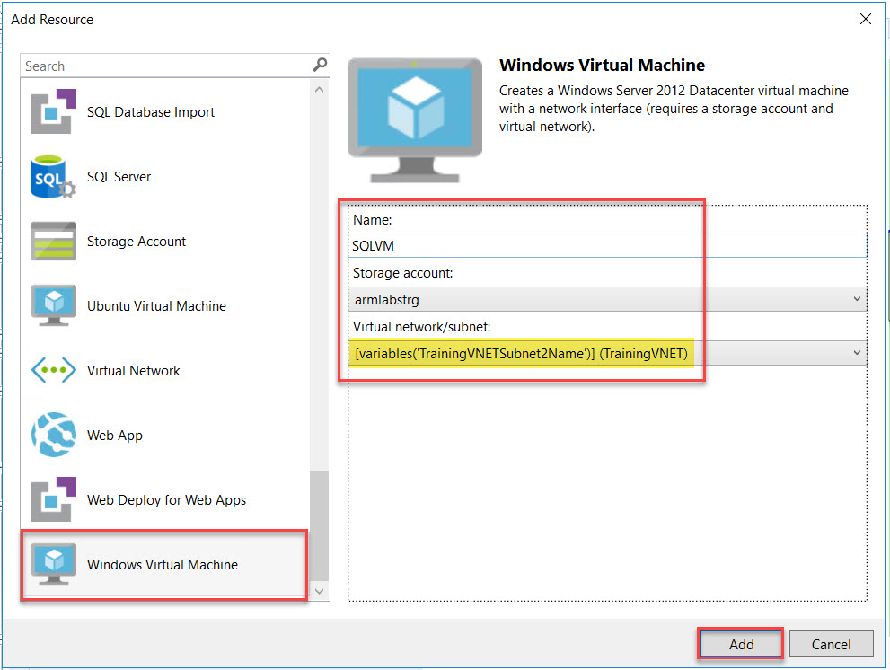

Step 24: Select **SQLVMVmSize** parameter

Change to **Standard_DS1_v2**

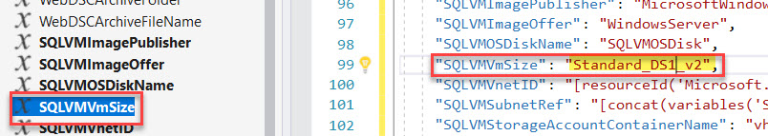

Step 25: Select SQLVMImagePublisher and SQLVMImageOffer variables.

"SQLVMImagePublisher": "MicrosoftSQLServer",

"SQLVMImageOffer": "SQL2014SP2-WS2012R2",

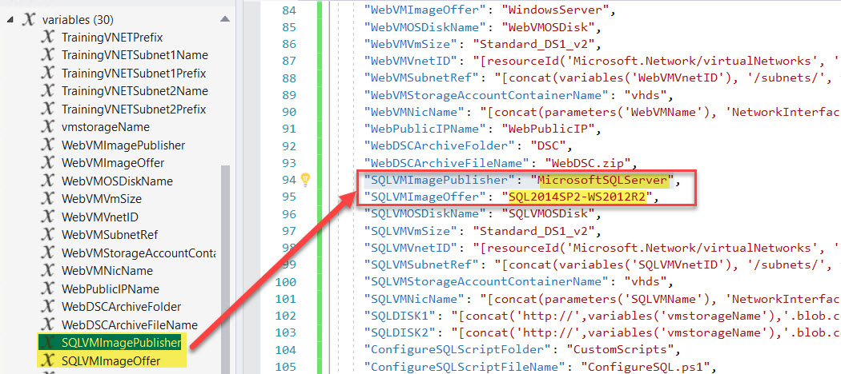

Step 26: Navigate to **SQLVMWindowsOSVersion** parameter and **delete** it.

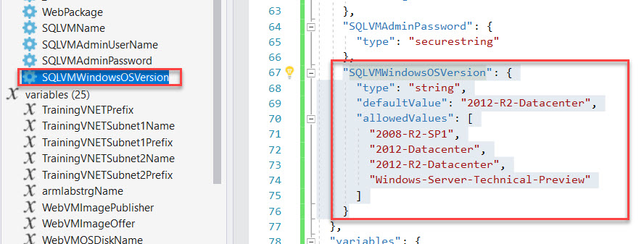

Add SQLVMSKU parameter

"SQLVMAdminUserName": {

"type": "string",

"minLength": 1

},

"SQLVMAdminPassword": {

"type": "securestring"

},

"SQLVMSKU": {

"type": "string",

"defaultValue": "Web",

"allowedValues": [

"Web",

"Standard"

]

}

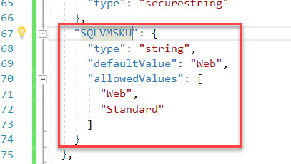

Step 27: After removing parameter error line will be there

Select **SQLVM** resource rename sku parameter **SQLVMWindowsOSVersion** to **SQLVMSKU**

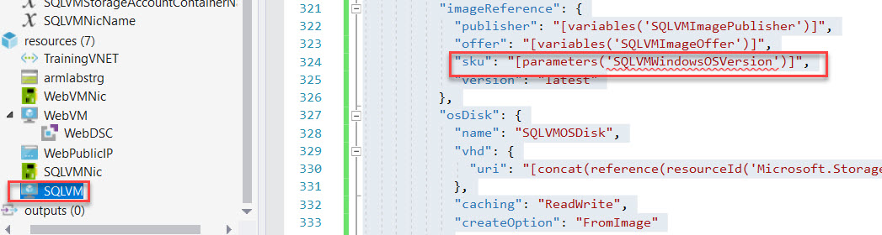

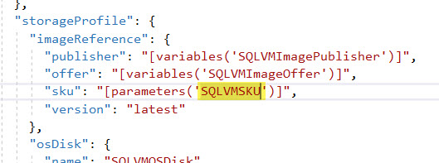

Step 28: Select **SQLVMNicName** and **Update storage account name**:

"SQLDISK1": "[concat('http://',variables('armlabstrgName'),'.blob.core.windows.net/','vhds','/','dataDisk1.vhd')]",

"SQLDISK2": "[concat('http://',variables('armlabstrgName'),'.blob.core.windows.net/','vhds','/','dataDisk2.vhd')]"

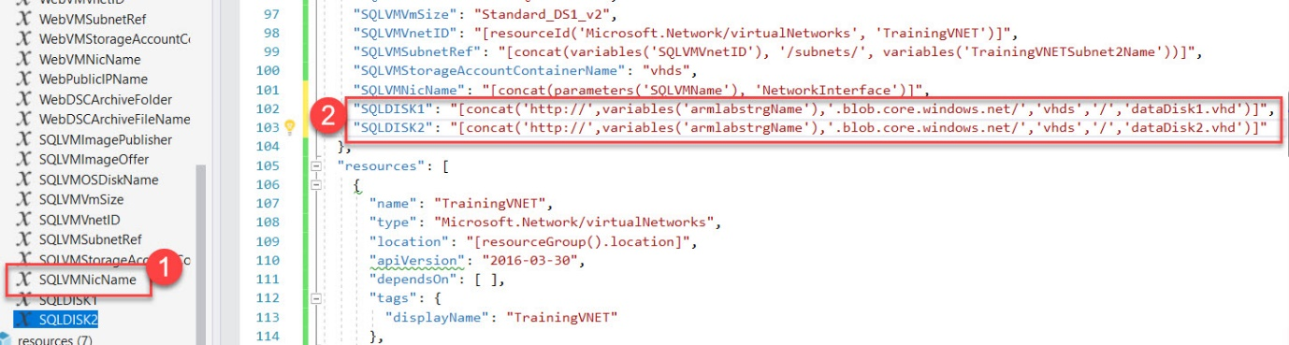

Step 29: Now add two extra data disk to SQLVM

Select SQLVM from resources

Add comma after osDisk

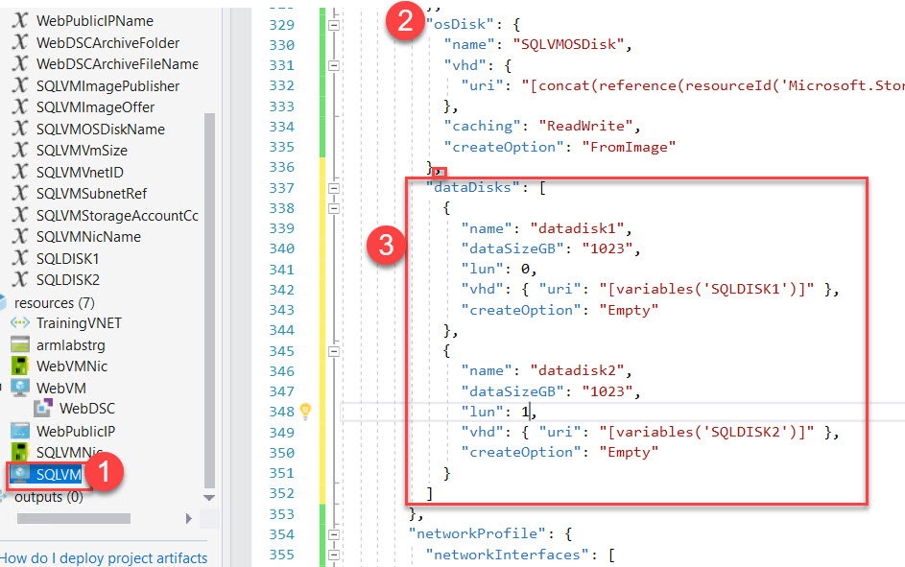

"dataDisks": [

{

"name": "datadisk1",

"diskSizeGB": "1023",

"lun": 0,

"vhd": { "uri": "[variables('SQLDISK1')]" },

"createOption": "Empty"

},

{

"name": "datadisk2",

"diskSizeGB": "1023",

"lun": 1,

"vhd": { "uri": "[variables('SQLDISK2')]" },

"createOption": "Empty"

}

]

Step 30: Add New Resource

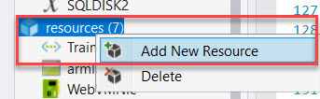

Search for Custom Script for Windows Extension

Name: ConfigureSQL

Virtual Machine: SQLVM

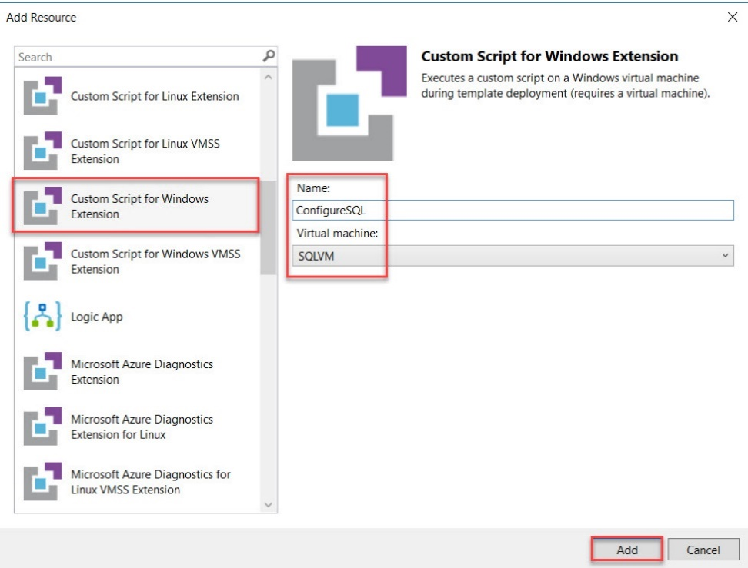

Step 31: Open **ConfigureSQL.ps1**

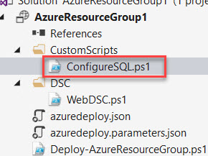

Remove all code.

Open **ARMSQL.ps1.txt**

**Copy and Paste into ConfigureSQL.ps1**

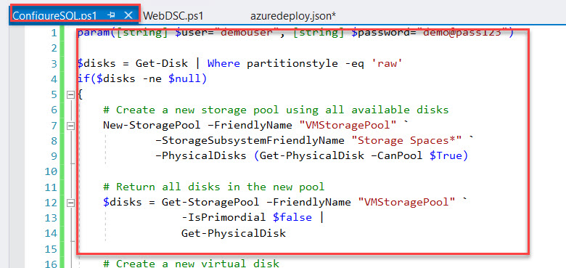

Step 32: This extension requires the local administrator credentials passed to it at deployment time. To accomplish that, switch back to the azuredeploy.json file and add a new variable at the end of the Variables section.

Add **Comma**

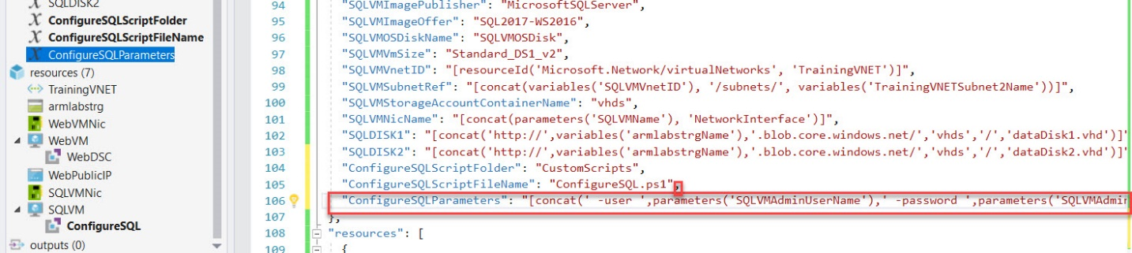

"ConfigureSQLParameters": "[concat(' -user ',parameters('SQLVMAdminUserName'),' -password ',parameters('SQLVMAdminPassword'))]"

Step 33: Select ConfigureSQL resource

**autoUpgradeMinorVersion** attribute will automatically use the latest minor version of the customScriptExtension. To avoid the risk of automatic updates breaking your script, set this property to falseon the ConfigureSQL custom script extension.

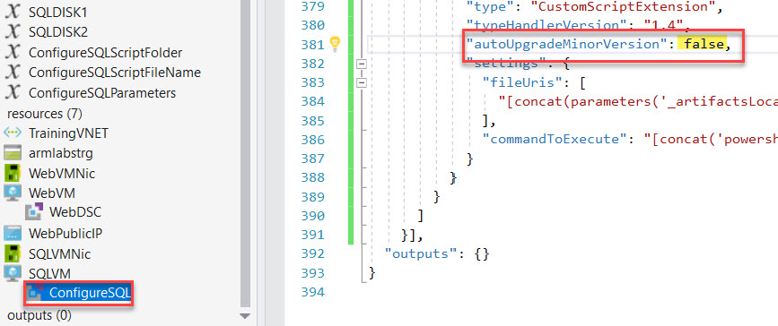

Step 34: Find the line that begins with "**commandToExecute**", and replace the entire line with the following

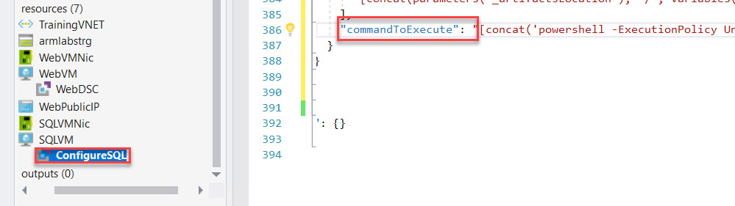



"commandToExecute": "[concat('powershell -ExecutionPolicy Unrestricted -File ', variables('ConfigureSQLScriptFolder'), '/', variables('ConfigureSQLScriptFileName'), ' ', variables('ConfigureSQLParameters'))]"

Step 35: Right Click on **Project Name -> Deploy -> ARMLabRG**

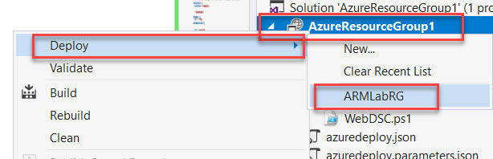

Step 36: Click on **Edit Paramteres….**

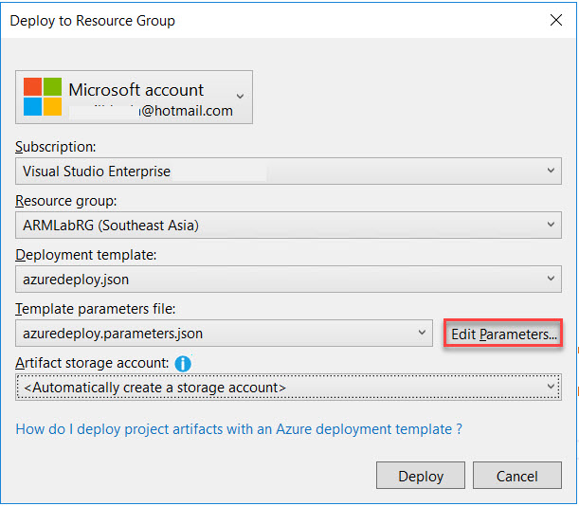

WebVMName: **armweb**

WebVMAdminUserName: **demouser**

WebVMAdminPassword: **demo@pass123**

WebPublicIPDnsName: **(Enter any unique name) ex. armpip19**

SQLVMNAme: **armsql**

SQLVMAdminUserName: **demouser**

SQLVMADAminPassword: **demo@pass123**

Check mark save passwords as plain text in the parameters file and Save button.

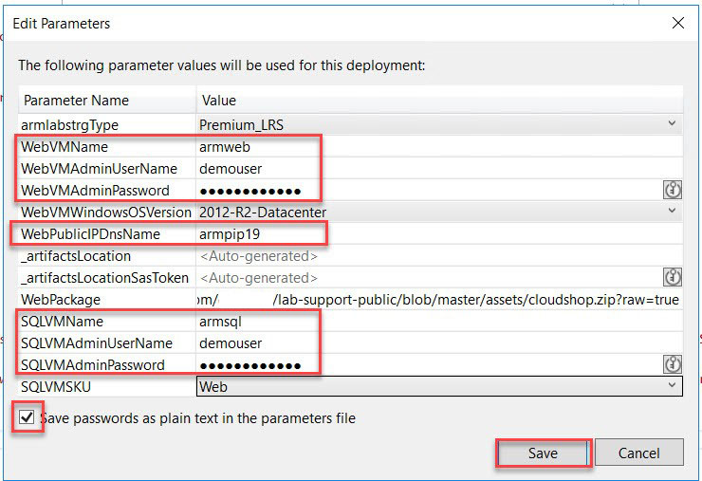

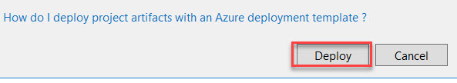

Step 37: Navigate to Azure Portal and **Copy-Paste DNS Name** in Browser

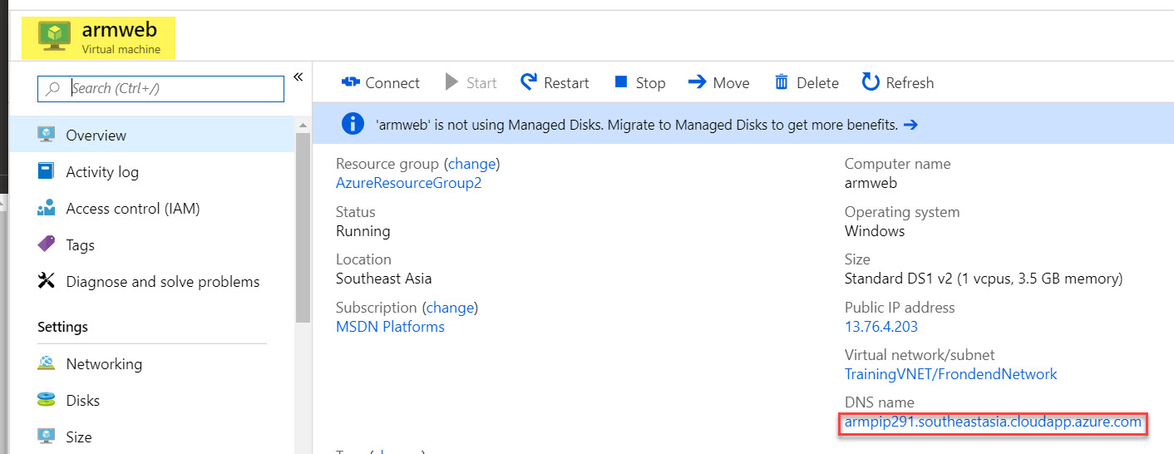

Website with Database will load

